Chapter 1
INTRODUCTION
1.1 Overview
This paper represents a review on multilingual document analysis in Indian context. India is having more than 22 official language, every script has its own characteristics and features based on their unique feature we can distinguish one language script with another. To distinguish different languages this paper focuses on four different operations, such as; preprocessing, segmentation, feature extraction and classification.Multilingual handwritten/printed document is provided as input. The input document consists of multi-languages. This language has its own vowels, consonants, maatras and vottakhsharas.Preprocessing of input image is done to remove noise. The hard copy of the document is converted into digital image by using scanning machine, obtained digital document may contain some amount of noise due to the quality of scanning machine or from source document quality.

In Image Binarization: The gray tone image is considered as an input image for this technique. The gray image is having intensity value range between 0 to 25. Size normalization is implemented to make the uniformity in character size. So that it can be fit for suitable matrix format and all data will be in same size. Segmentation: The preprocessed image is segmented in to lines, words and characters. Feature extraction: The process of extracting valuable information from input image is known as feature extraction. This method reduces pattern variability at the time of analysis and identification. The pattern generated is unique in nature due to its special features. Classification of segmented document in to different scripts and languages: This method will classify all the input images into different classes based on the features which are extracted from feature extraction technique. The classification is carried out in two ways, such as rule based classification that is "if.. . then .. ,," rules form. The descriptive models are generated by using rule based classifier which is very easy to interpret but gives very good performance to decision tree classifier.

  - Background Knowledge
The learning materials are vastly available on various platforms. To allow students be comfortable on using the learning materials is the basic motive. It should have various characteristics for it to be really useful to the students. This includes:
- It should be very accurate and precise.
- It should be extremely fast on the topics being searched for.
- An integrated environment for all the multimedia learning materials on single platform.
- It should be friendly on servicing the user queries.
- It should give related concepts on relative to the topics searched for.
The above points were kept in mind and various techniques were proposed. The techniques had the major concepts like meta data for quick access or retrieval of data, indexing on accessing the searched terms at a faster rate and some image processing techniques to extract content from slides and videos. Ultimately, a cumulative system to combine all the search techniques was proposed which was none other than the Ultimate Course Search (UCS) tool such that it could integrate all the requirements and combine all the techniques for one platform.

Chapter 2
DETAILED LITERATURE SURVEY
  - Multi-Term Keywords for Indexing Multilingual Textual Repositories: Developing Language Resources and Algorithms. (2006)
In this paper, the first part of the procedure extracts mono-term keywords from the text. . Keywords are crucially identified within the nominal lexicon. The term frequency (TF) of all nouns in the input document is compared by the tool to their distribution in the general corpus (inverse documents-frequency, IDF). For a word w in a given document, the weight of the term in the document is:
T F.IDF(w) = T F(w) log µ N DF(w)
where T F(w) is the number of occurrences of w in the input document, DF(w) is the number of documents of the general corpus containing w, and N is the total number of documents in the corpus.
Words that are more frequent in the input document and less spread over the different documents of the corpus are the best candidates to represent the document itself, and they receive an higher score of “key-ness”. The following example shows the results of T F.IDF on a text about the fall of house prices in London:
Keyword | Score
price | 114.471
house | 76.3143
market | 61.0515
rate | 61.0515
growth | 49.9475

first 5 highly ranked keywords; source: http://timesonline.co.uk
The list of extracted mono-term keywords is then processed by the semantic component. Since the nouns in the list are potentially ambiguous with respect with their semantics, a word sense disambiguation (WSD) procedure is run over these words. Semantic Similarity (SS) among synsets related to the keyword candidates is then estimated, through the Lesk’s distancemeasure [3], on the WN lexical database. The SS is exploited to operate WSD: for each candidate, the synset with the highest SS score is preferred and associated to the keyword, generating a list of unambiguous lexical concepts suitable for translation.

2.2 Multilingual Sentiment Analysis Using Latent Semantic Indexing and Machine Learning (2011)
In this paper, cross-language sentiment analysis has only two prerequisites:
(a) A parallel (multilingual) corpus
(b) Documents in at least one language which are tagged according to sentiment
A sentiment tag is created for a parallel document. Each token from the document is assigned with a valence and the frequency of the token is multiplied with the valence. Once the initial pre-chapter valence scores are obtained it is sorted, the chapters with the top 100 and bottom 100 values for valence.
In latent semantic indexing (LSI) framework a term by document matrix X is factorized
X = USV T
Each column vector in U maps the terms in the corpus to a single arbitrary concept, such that semantically related terms will tend to group together with similar values in columns of U.
S- Reduced number of concept dimensions.
To be assumed that X is a five-language multi-parallel corpus. Columns represent documents, the intersection of columns with the band for language K contains the weighting of terms in the translation of documents into language K.
The overall method is projecting all of the sentiment-tagged chapters from the English documents into multi-lingual concept space and collecting all of the resulting feature vectors into a single training set to build a prediction model on that training data and use it to predict the sentiment of same chapters in other languages.
.
2.3 Cross-Lingual Document Similarity (2012)
In this paper, it is shown that Individual documents are represented as vectors by using the standard vector space model where each term corresponds to a word or a phrase in a fixed vocabulary. An aligned corpus is represented by a set of matrices DJ defined as DJ := [d^{j}₁, ... ,d^{j}_{m}] ϵ R^{n}_{j*}^{m} where m is the number of documents in the aligned corpus and n_{j} is the dictionary size. Let N = ∑^{M}_{J=1} n_{j}, where M is the number of languages.
All the term-document matrices into a single matrix by stacking the individual term-document matrices and discarding nonaligned documents. D_{Total} = [D^{1T},D^{2T}…D^{MT}]^{T} such that the columns respect the alignment of the documents. Therefore, each document is represented by a long vector indexed by the terms in all languages. These vectors determine the similarity on which the k-means is computed. The algorithm outputs a set of centroids that are then separated to form an aligned basis. As a final step the the projected documents are computed as the least squares solutions.

Data Set
To investigate the empirical performance of the low rank approximations is tested on the algorithms on a large-scale, real-world multilingual dataset that is extracted from Wikipedia by using inter language-links as an alignment. This results in a large number of weakly comparable documents in more than 200 languages. Wikipedia is a large source of multilingual data that is especially important for the languages for which no translation tools, multilingual dictionaries as Eurovoc, or strongly aligned multilingual corpora as Europarl are available. Documents in different languages are related with so called 'inter language' links that can be found on the left of the Wikipedia page. The Wikipedia is constantly growing. There are currently four Wikipedias with more than 106 articles, 40 with more than 105 articles, 100 with more than 104 articles, and 216 with more than 1000 articles. Wikipedia uses special user-friendly markup language that is very easy to write but very hard to parse. Simplicity of language can cause ambiguities and moreover it is constantly changing. For example, separator I can be used in different contexts. Wikipedia raw xml dumps of all currently 270 active editions were downloaded from the Wikipedia dump page http://dumps.wikimedia.org. The xml files are too large to be parsed with DOM like parser that needs to store the whole xml tree in the memory, instead we implemented Sax like parser that tries to simulate behavior of Wikipedia official parser and is as simple, fast and error prone as possible. Each Wikipedia page is embedded in the page tag.
First we check if the title of the page consists of any special namespace and do not process such pages. Then we check if this is a redirection page and we store the redirect link as inter-language links can point to redirection link also. If nothing of the above applies we extract the text and parse the Wikipedia markup. Currently all the markup is removed. We get inter-language link matrix using previously stored redirection links and inter language links. If inter-language link points to the redirection we replace it with the redirection target link. It turns out that we obtain the matrix M that is not symmetric, consequently the underlying graph is not symmetric. That means that existence of the inter-language link in one way (i.e. English to German) does not guarantee that there is an inter-language link in the reverse direction (German to English). To correct this we transform this matrix to symmetric by computing M + MT and obtaining an undirected graph. In the rare case that we have multiple links pointing from the document, we pick the first one that we encountered. This matrix enables us to build an alignment across all Wikipedia languages.
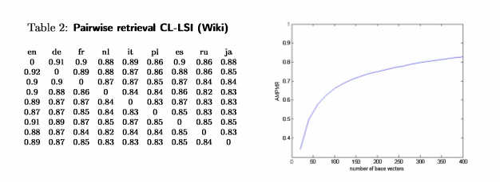
Figure 2.3.1: AMPMR and number of base vectors (Wiki)

2.4 Combining Modern Machine Translation Software with LSI for Cross-lingual Information Processing Roger (2014)
In this paper, The LSI technique applied to a collection of documents consists of the following primary steps:
- A matrix A is formed, wherein each row corresponds to a term that appears in the documents, and each column corresponds to a document. Each element am,n of the matrix corresponds to the number of times that the term m occurs in document n.
- Local and global term weighting are applied to the entries in the term-document matrix.
- Singular value decomposition (SVD) is used to reduce this matrix to a product of three matrices: A = USVT where U and V are orthogonal matrices and S has nonzero values (the singular values) only on the diagonal.
- Dimensionality is reduced by deleting all but the k largest values of S, together with the corresponding columns in U and V. This truncation process is used to generate a k-dimensional vector space. Both terms and documents are represented by k-dimensional vectors in this vector space.

Cross-lingual application of LSI relies on use of a parallel corpus to establish the relationships among terms from multiple languages in a single LSI space. For two languages - for example, English and French - each English-language document and its French-language equivalent (translation) are treated as a single document in creating the term-document matrix A. Once the combined documents have been formed, they are used in the creation of the LSI space.

2.5 Semi-Automatic Indexing of Documents with a Multilingual Thesaurus (2003)
In this paper, a method a review on multilingual document analysis in Indian context is proposed. Each individual script is having unique style of writing and letters. The features of character depend on the structural and statistical properties, which generally differs from one script to another. The manual identification of language may be tedious and time consuming. The automatic identification and recognition of language also helps in text area identification, document sorting in digital libraries while dealing with multilingual documents.
The factors which are important for script identification are:
1. Preprocessing.
2. Feature extraction and classification.
3. Computation speed.
4. Variation in text in document such as variation might be font style, size and document skew.
5. The performance of script identification.
The proposed paper contains research review on multilingual document analysis on Indian context. In most of the script having its unique vowels and consonants which are independent characters known as basic characters. The combination of consonants and vowels along with diacritical marks forms modifiers and the characters so formed are known as conjuncts. Sometimes two or more consonants can combine and take new shapes. These new shape clusters are known as compound characters. The multilingual document analysis system may contain handwritten or printed multi script document image as an input for analysis of document image to recognize and classify the different scripts for analysis and identification.
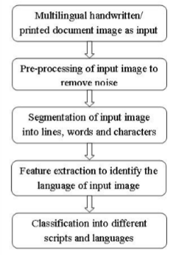
Figure 2.5.1: Flow of multilingual document analysis
- 1.Multilingual handwritten/printed document as input image: The input document is consisting of multi-languages. For this research work we are mainly focusing on English, Hindi, and other Indian regional languages. This document will act as input document. This language has its own vowels, consonants, maatras and vottakhsharas.
- Preprocessing of input image to remove noise: The hard copy of the document is converted into digital image by using scanning machine, obtained digital document may contain some amount of noise due to the quality of scanning machine or from source document quality. For the purpose of language identification this methodology is focusing on noise free and skews free document images. The scanned images are gray tone images. We have to convert the image into the binary image. This preprocessing includes following technique: Image Binarization: The gray tone image is considered as an input image for this technique. The gray image is having intensity value range between 0 to 25. To convert gray image into binary image some threshold value need to be fixed, if the intensity value which is greater than or equal to threshold value than those value will be represented as 1 otherwise O. In binary image O's are used to represent black and 1 's are used to represent white pixels. Noise reduction: The input image document is generated through optical scanning machine and there is a possibility that it may contain certain noise at the time of scanning or due to writing instrument or disconnected line segments or gaps present in the line, etc., It is necessary to eliminate these noise present in the image document through preprocessing. Size normalization is implemented to make the uniformity in character size. So that it can be fit for suitable matrix format and all data will be in same size. Thinning process is executed on input image document which might contain text with varying thickness, to make uniformity of text the thinning process is implemented through boundary detection of images.
- Segmentation: The preprocessed image is segmented in to lines, words and characters. The mostly occurred problem in segmentation is - it causes confusion between text and graphics in case of joined and split characters. Usually, splits and joints in the characters causes due to scanning. First the input document is segmented as line then to word and characters.
- Feature extraction: The process of extracting valuable information from input image is known as feature extraction. This method reduces pattern variability at the time of analysis and identification. The pattern which will be generated is unique in nature due to its special features. These unique patterns are very useful to distinguish different class from one another.
- Classification of segmented document in to different scripts and languages: This method will classify all the input images into different classes based on the features which are extracted from feature extraction technique. The classification is carried out in two ways, such as rule based classification that is "if.. . then .. ,," rules form. The descriptive models are generated by using rule based classifier which is very easy to interpret but gives very good performance to decision tree classifier. To handle data set with imbalance class distribution the class based ordering technique is also by rule based classifier. There are many other classification techniques. Depending on the features extracted a specific classification technique may be chosen.

Detailed overview of the Literature survey:
Paper Title | Year | Problem Addressed | Observations | Drawbacks (if any)
1. Multi-Term Keywords for Indexing Multilingual Textual Repositories: Developing Language Resources and Algorithms. | 2006 | Presents a method for translation of documents from one language to other by the use of key word extraction and grouping them accordingly. | Extracts key nouns from the text. The list of extracted mono-term keyword is then processed by semantic component. Symantec similarity among these words are then estimated . The synset with highest semantic similarity score is preferred and associated to keyword, generating a list of unambiguous lexical concepts suitable for translation. | Certain words must be repeated at least more than one time.
2. Multilingual Sentiment Analysis Using Latent Semantic Indexing and Machine Learning | 2011 | Predicting the sentiment of documents in multiple languages using machine learning approach | Projecting all of the sentiment-tagged chapters from the English documents into multi lingual concept space and collecting all of the resulting features vectors into a single training set to build a prediction model on that training data and use it to predict the sentiment of same chapters in other language | Sentiment tagging to each chapter must be done manually
3. Cross-Lingual Document Similarity | 2012 | Compute the cross-lingual similarities based on the K-means algorithm on an aligned multilingual corpus. | Individual documents are represented as vectors and are converted to term-document matrices. All term- document matrices are merged into a single matrix to apply the K-means algorithm. The algorithm outputs a set of centroids that are then separated to form an aligned basis to obtain the computed solution.
- Combining Modern Machine Translation Software with LSI for Cross-lingual Information Processing | 2014 | This paper presents the method for translation of documents from one language to other by combining Modern Machine Translation Software with LSI for Cross-lingual Information Processing | A matrix A is formed, wherein each row corresponds  to a term that appears in the documents, and each  column corresponds to a document. Each element am,n  of the matrix corresponds to the number of times that  the term m occurs in document n.  Both terms and  documents are represented by k-dimensional vectors. The relatedness of any two objects represented in the space  is reflected by the proximity of their representation vectors. For cross-lingual LSI each language document and its equivalent are treated as single document in creating LSI. | Certain words must be repeated at least more than one time
- A Review on Multilingual Document Analysis in Indian Context | 2016 | Language identification in multi lingual documents through document image analyses | Multilingual handwritten/printed document is provided as input image. Preprocessing of input image to remove noise.Segmentation of the processed image. Feature extraction from the image. Classification of segmented document in to different scripts and languages | The proposed system is time-consuming on interactions with the user.

Chapter 3
METHODOLOGY
3.1 Earlier methods vs Current method
Many universities are offering online degrees through web sites powered by learning software. For each course/section, the lectures with links to the lecture videos and the presentations are made available to the students. A student who selects a particular lecture has to go through the entire slide presentation or the lecture video until she finds what she is looking for. Current software platforms used to manage education materials do not provide search capabilities in general. This can be grouped into two prototypes.
First generation Prototypes

Second generation Prototypes
Table 3.1.1: Earlier methods/ Prototypes
3.1.1 First generation Prototypes
The first-generation prototypes developed in late 1990s and early 2000s were characterized by a large amount of human involvement. The approach is taken to segment the video stream based on the presentation timestamp in order to synchronize the video with the slides. The transition timestamp points are manually edited to ensure correctness. The Classroom 2000 project introduced a presentation tool called ClassPad, which uses an electronic whiteboard to present the slides along with the instructor’s annotations. The slides are converted into GIF images and the instructor adds the annotations using a pen. The students are also provided with a similar interface allowing them to add personal notes to the presentations. The problem with this approach is that editing the timestamps manually is time consuming.

The BIBS lecture webcasting system provides a lecture review tool on lectures recorded using proprietary software that synchronizes the slides and the videos. It is limited in the sense that it cannot handle videos that have not been recoded with the provided software. The authoring system also provides a search interface. The transition detection is based on pixel processing after the images extracted from the videos have been binarized. The major problem in this approach is that pixels are often very noisy and unreliable.
3.1.2 Second generation Prototypes
The prototypes in the second generation are more recent and use more automation. TalkMiner is aimed at general talks and is limited to videos. Talk-Miner provides an interface where the user can browse through talks and search for specific keywords. The keywords are extracted from the videos directly using optical character recognition (OCR). The text extracted is used to build indexes to support the search. OCR techniques are slow and not always reliable especially when the quality of the videos is low. This can impact the search accuracy especially if the same technique is to be used on course videos.
The prototypes rely on the audio layer for annotation. A video browsing tool is developed using speech transcripts to generate keywords for indexing. EdX presents lecture videos organized in topics and offers the possibility to jump to specific video segments. The video segmentation is based on the text transcript that has to be provided by the instructor. The audio track usually generates large number of keywords and most of them do not appear in the slides. The accuracy of keyword generated is entirely dependent on the speech processing engine, and is low with the state-of-art technology.
3.1.3 Ultimate Course search tool (UCS) : The current method
Slides
Videos
Textbook
Ultimate Course Search

Figure 3.1.3.1: UCS tool
UCS integrates different media like textbook, video, and slides and relies on image processing techniques to synchronize the videos and the slides.
3.2 Video Pre-Processing
Educational videos capture the content of power-point slides but also the instructor explanation of the slides. In order to make the videos searchable, they are to be segmented based on the slides that are being presented in the video. The slide transitions in the video (i.e., the points in time where a new slide appears) must be known. It should be found exactly when the video starts discussing a particular slide and the end time of the video segment associated with a particular slide. This information is used to build the video index and generate a mapping between segments of the video and the slides in the corresponding lecture presentation.
Two kinds of videos that are commonly used: (a) Videos shot in a classroom and (b) Screen capture videos where the instructor uses dedicated software to capture the computer screen. Unlike the latter which may be accompanied by metadata generated by the recording software, the former are captured by regular cameras and are more difficult to process as they do not contain any metadata about the lecture. In order to automatically segment such lecture videos, it relies solely on image processing techniques.
The histogram of oriented gradients (HOG) is used to determine slide transitions. After finding the transitions in the videos, it is verified that the slides in the video correspond to the slides in the presentation as they might not appear in the right order, or instructor may skip some of them. They again use HOG features from the slides converted into images to match the video frames in order to establish the correspondence between slides and video segments.
3.2.1 Transition Detection technique
Key-frames are picked and the Euclidian distance is calculated between the feature vectors of consecutive key-frames. The easiest approach to selecting key-frames is to pick a frame every m second. A small value of m will increase the accuracy but also the processing time, whereas transitions will be missed if m is too large. The transitions must be known in order to select an optimum value of m (the minimum time interval between two consecutive transitions). The two consecutive key-frames are different if the distance between their HOG vectors is above a certain threshold t.

3.2.2 Transition Detection: Experiment Results
They used 14 different lecture videos of different quality for the experiments ranging from 30 minutes to 4 hours.
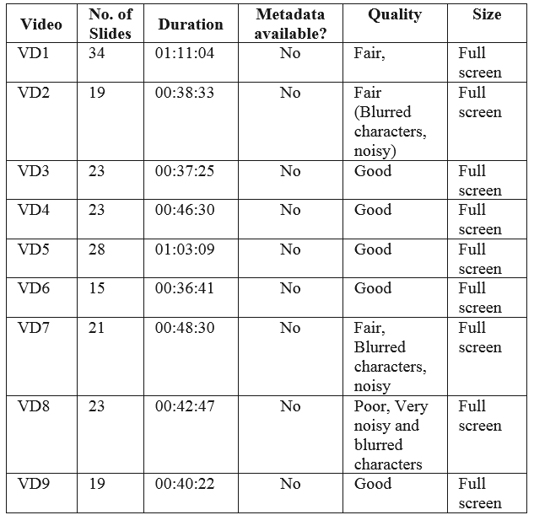
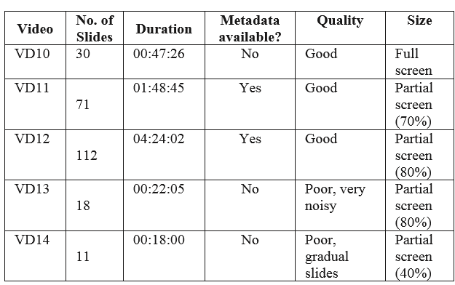
Table 3.2.2.1: Video Datasets
- The videos VD1 to VD10 are recorded with regular cameras and, videos VD2, VD7 and VD8 are of lower quality. All these videos are full screen videos. That is, the camera was on the slides all the time.
- Videos VD11 to VD14, need preprocessing: they first extracted the slide regions from the frames before computing the feature vector using HOG.
- Videos VD11 and VD12 were recorded using Camtasia and have metadata. However, the instructor was fast rewinding and fast forwarding at some point. As a result, the metadata file generated by Camtasia had incorrect slide numbers and incorrect slide transitions. In addition, VD11 and VD12 have slide covering partial frames ranging from 70% to 80% of the frame. Both sets of videos were provided to us by two different instructors.

- Videos VD13 and VD14 were the most challenging lecture videos. Both are of poor quality and included frames with slides and the presenter. They have poor illumination and contain camera effects and slide occlusion. Video VD14 has both the presenter and the slide in some of the frames, with the slide covering only 40% of the screen.
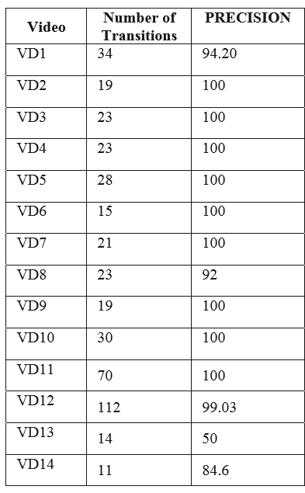
Table 3.2.2.2: Precision for Detecting Transitions Using Hog
The experimental results on the transition detection is shown. As expected, the detection quality is low for VD13 and VD14. The precision for VD13 is low due to number of false positives which results from the camera effects. In addition, the instructor went back to previous slides several times during the lecture.
3.2.3 Slide Matching
It is not always the case that the slide presentation files provided are the ones used during the recording of the corresponding videos. Even if the presentation file is the right one for a video, there is no guarantee that the slides will appear in the right order. Several times, the slides are found in the presentation file that were hidden or skipped during the recording. The slide matching phase allows to make sure that they are indexing the right files and also helps to correct some of the transition detection problems.
The slide matching phase consists in matching a slide found in a video frame with the actual power-point presentation slide converted into image. They convert the power-point slides into images in order to compare their features with the features of the slides extracted from the video frames. Since the instructor can skip slides, we select a frame between two transitions and compare it against a number of slide images in a slide window. The distance between the HOG of the frame and the HOGs of the slide images in the slide window was computed. As shown below, the slide matching phase further improved the transition accuracy.
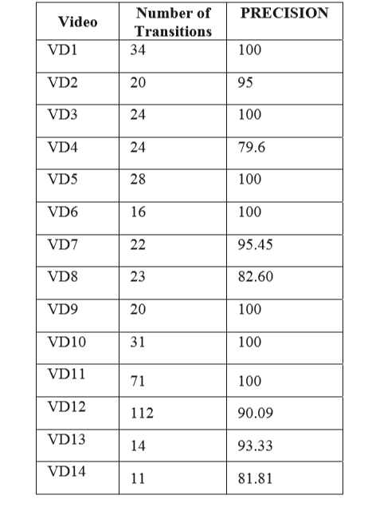
Table 3.2.3.1: Slide Matching Results
The accuracy has improved in all videos except VD4, VD8 and VD14, for which, the video quality was the major issue.

3.3 Multimedia Learning Material Indexing and Ranking
In order to make the multimedia learning materials searchable, they must be indexed by their learning content. They generate separate indexes for slides, videos and textbooks. The slides are indexed on the keywords extracted from PowerPoint presentation and the videos are indexed on the slides. The electronic textbooks are indexed on page numbers using the back index provided by the textbooks.
3.3.1 Indexing
- Slides as a roadmap to learning material annotation
Power-point slides are commonly used in teaching. They are carefully prepared by the instructor of the course who is often an expert in the area. In that sense, they represent an expert input to the indexing process. The text in the slides is processed using classic text processing techniques such as tokenizing, stemming and stop words removal.
Each extracted word is compared against the course ontology when available or the textbook index. Notice that, the taxonomy provided by the course textbook index is the simplest form of ontology. Every Textbook has an index provided at the end of the textbook that lists the most important terms covered by the book and the pages where they appear. This index also called as back index is provided by an expert and contains the most important learning concepts. Indexing only the keywords in the slides that appear in the textbook index helps us reduce the number of keywords from the slides to be indexed.
Every slide essentially contains a structure and text content. They divide the slide into several regions such as title, sub-titles (if they exist) and body. For each keyword previously extracted from the slide text content, it is stored in its region-based information (e.g. slide title, subtitle, and text), that is, the region where the keyword occurs in the slide. This ensures that in the ranking stage the relevant results appear at the top.

- Video Indexing
The slide-video index contains the information about slide number and presentation details they are associated with, along with start and end time of each video segment associated to that slide. When a user searches for a keyword, the keyword is first searched in the slide index and the relevant slides are returned as search result. The Slide-video index is then used to retrieve the corresponding video segments.
- Textbook
In order to look up any particular keyword in a textbook, it is seen that normally they look at the back index of the textbook which provides them with a page number, the topic or term that appears in the textbook. They make use of the same concept. Here, they parse the back index of the textbook to fetch all the keywords and their associated page numbers.
3.3.2 Keyword Appearance Region Prioritized Ranking
The classical document search based on term frequency– inverse document frequency (TF/IDF) alone will not yield the desirable result here as a high frequency of a term in a slide does not necessarily mean that the term is defined in that slide. The heuristic is used, that if a keyword appears in the title then it is likely that the slide is about the term. The region is divided into two parts, title and body which correspond to the slide title and slide text respectively. To calculate the score for an individual slide (document), we use the tf/idf measure and attach a weight depending on the region where the query term appears. If the query term appears in the title region, we give it a higher weight than the body. On the other hand, if the keyword appears in the body of the slide, it is given relatively lower weight. Given a query q composed of the terms t1, …., tn, the score of a document (slide in our case) d is computed as follows:
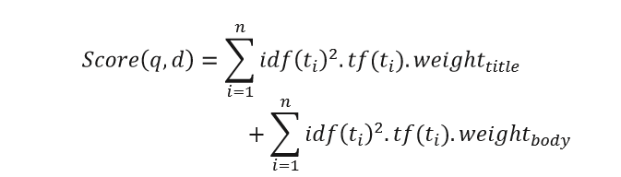

Where weight_{title} is the weight applied if a query term t_{i} appears in the title, weight_{body} is the weight applied when the term t_{i} appears in the body, tf (t_{i}) is the term frequency of the term in region (title or body) within the document, and idf(t_{i}) is the inverse document frequency for t_{i}. Notice that weight_{title} > weight_{body} and both values are greater than 1. The weight weight_{title} is used to boost the score, when q query keyword appears in the title of the slide. The scores of individual slides in a presentation are aggregated to obtain the score of the presentation.
The presentations are ranked according to their total score of relevance. The weights are determined experimentally and assigned such that the weight of the presence of a keyword in the presentation title is higher that weight given when the keyword appears in the slide title or the subtitles of the slide text.

Chapter 4
Results and Discussion
4.1 UCS Functionality
The techniques presented above have been implemented in the Ultimate Course Search (UCS) tool. UCS integrates learning material from different media and allows them to be searched and viewed through a single interface. A student viewing a particular slide can also view its associated video segment and the corresponding textbook pages. The application is written in Java. Here, they use Apache Tomcat as the webserver and Apache Lucene to implement the indexes.

UCS provides two types of search: the first type is on slides and videos combined, and second is on textbook. When the user provides a keyword in the search bar of the slide and video interface, all the slides and corresponding video segments that match with this keyword are displayed in the order of relevance. The top 20 results matching to a keyword are returned. When a user types in a keyword, she is presented with suggestions based on the keywords that are extracted from the power-points. Upon clicking the slide/video button, internally Apache Lucene uses the slide index to fetch all the slides that contain the keyword.

Then, they prioritize the results according to the region-based scheme and the results are returned on the left side of the interface as shown. The results are displayed as a list of links where each link corresponds to an individual slide that contain the keyword. The links corresponding to slides from the same presentation are grouped together (i.e., presented consecutively). Upon selecting a link, a particular slide can be viewed in the display area on the right.

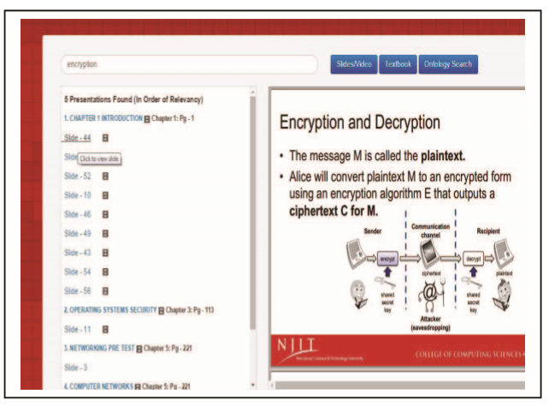
Figure 4.1.1: Slide/Video Interface (Slide selected)
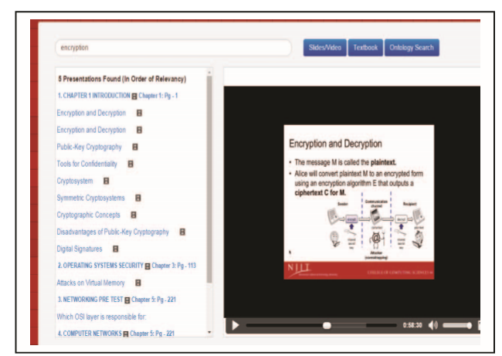
Figure 4.1.2: Slide/Video Interface (Video selected)
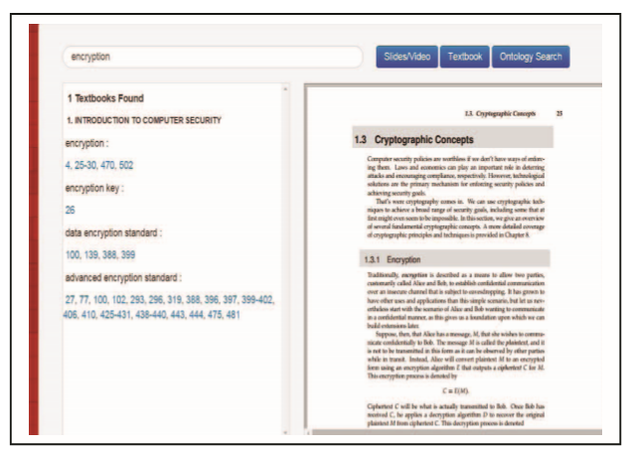
Figure 4.1.3: Textbook Interface
If the user wants to view the corresponding lecture video, then he/she can click on the video icon in the search results and only the part of the video that is about this slide is played. The user does not have to go through the entire video to understand a topic. After a search, the user can also freely drag the cursor to play any part of the entire lecture.

Chapter 5
ADVANTAGES AND DISADVANTAGES
5.1 Advantages of the model
The model presented has the following advantages:
- Multimedia enhances the effect of text presentations.
- Improves the quality of presentation and retains the attention of audience. It is quick and easier to operate for the instructor.
- Multimedia presentations can be modified very easily.
- Multimedia is Entertaining as Well as Educational.
- A friendly, accurate and precise model is developed.
- The proposed model is fast and advancing.
- Easier to analyze once organized.
5.2 Disadvantages of the model
The UCS tool has several advantages while disadvantages too. It includes the following:
- Non-interactive – if one-way, no feedback.
- Complex to create.
- Time consuming.
- Use of multimedia is expensive.

Chapter 6
APPLICATIONS
The UCS tool is amazingly useful exclusively in a particular field. Barely, the multimedia materials have extensively be used in today’s world. Multimedia and its related applications have almost become synonymous with modern technology, given the kind of explosion the technological realm has seen. Although multimedia materials with UCS can be used in the following applications for tasks to be much easier. This includes:
- Exciting presentations are used to grab and keep attention in advertising. (COMMERCIAL)
- Multimedia is used to produce computer-based training courses. Edutainment is an informal term used to describe combining education with entertainment, especially multimedia entertainment. (EDUCATION)
- Multimedia for software interfaces are often done as a collaboration between creative professionals and software engineers. (ENGINEERING)
- UCS can be used as a useful tool for online courses. (ONLINE TRAINING)

CONCLUSION
In this paper, it is presented about the Ultimate Course Search, which provides not only a very simple to use interface but also a very effective way to search heterogeneous lecture material. For making the learning material searchable, they index the three most widely used lecture mediums, slide, video and textbook. The slides are indexed by identifying relevant keywords from the slide. Its shown that without annotating the slides and videos it can be effectively linked to the material by storing the transition of slides in a video. The results show that finding the transitions automatically along with matching with the original slides helps us to identify better transitions.
UCS also offers search on the textbook by indexing the content from the back index of the textbook along with the page number information. UCS thus integrates these three-learning media into a single platform, which provides students a way to learn the material effectively and efficiently. The results presented to users after a keyword search are based on the region where the keyword appears. It is shown that, presenting the results in such a fashion brings the most important and relevant content on the top. Although the UCS prototype presented in this paper does not make use of the audio track, where it is believed that converting the audio into text will provide a richer search context for the slides and videos.
On conducting the user research on two sections of the same Computer Security Course at NJIT, the students of only one of the sections were given access to UCS. The study consisted in comparing the students who have access to UCS with students who did not have access to UCS. Both sections were taught by the same professor, using the same syllabus, assignments, and lectures. The attrition rate for the section utilizing UCS was 13% as compared to the attrition rate of 41% for the course without access to UCS. Students used the tool to study for their exam, watch lecture videos, search for specific terms and information, and to complete homework assignments and projects. Overall, the students using the tool found it to be user friendly, fast and accurate, and stated that it helped them understand difficult course concepts.

REFERENCES
- “Indexing Multimedia Learning Materials in Ultimate Course Search”, IEEE International Conference, 2016
- “Automated tagging to enable fine-grained browsing of lecture videos”, IEEE International Conference on Technology of Education, 2011
- “UCS: Ultimate course search”, IEEE International Conference on Technology of Education, 2016
- “Semi-Automatic Indexing of Documents with a Multilingual Thesaurus”, IEEE paper, 2003
- “TagTick: A Tool for Annotation Tagging over Solr indexes”, IEEE paper, 2014
- “Multilingual Indexing in an Intercultural Context”, IEEE paper, 2016
- Coursera. Coursera. https://www.coursera.org/.
- “Introduction to Information Retrieval”, http://nlp.stanford.edu/IRbook/

